THE MINISTRY OF HEALTH OF THE RUSSIAN FEDERATION

PATIENT INFORMATION LEAFLET

FOR THE DRUG PRODUCT

POLYOXIDONIUM®

Registration number:
Trade name: Polyoxidonium®
International non-proprietary name: Azoximer bromide (Azoximeri bromidum)
Chemical name: copolymer of 1,4-ethylene piperazine N-oxide and (N-carboxymethyl)-1,4-ethylene piperazinium bromide
Form of medicine: solution for injections and topical application
Each 1 mL contains:
Active substance: Azoximer bromide – 3 mg or 6 mg;
Excipients:
mannitol – 0.9 mg, povidone K17 – 0.6 mg (for 3 mg dosage),
water for injection – up to 1.0 mL.
mannitol – 1.8 mg, povidone K17 – 1.2 mg (for 6 mg dosage),
water for injection – up to 1.0 mL.
Description: colorless or yellowish liquid
Pharmacotherapeutic group: immune-modulating drug
ATC code: [L03]
Pharmacological properties
Pharmacodynamics
Azoximer bromide has combined immune-modulating, detoxifying, antioxidant, and moderate anti-inflammatory effects.
The immune-modulating effect of Azoximer bromide is based on its direct influence on phagocytic cells and natural killer cells, as well as its ability to stimulate antibody production and IFN-alpha and IFN-gamma synthesis.
Detoxifying and antioxidant effects of Azoximer bromide are mostly attributed to its structure and high-molecular nature. Azoximer bromide strengthens the body’s resistance to local and generalized bacterial, fungal and viral infections. It restores immune functions in patients with secondary immune deficiencies caused by various infections, traumas, surgical complications, burns, autoimmune diseases, malignant neoplasms, or the use of chemotherapeutic agents, cytostatics or steroid hormones. The use of Polyoxidonium® in patients with secondary immune deficiencies is a way to improve the efficacy and shorten the duration of treatment, significantly reduce the use of antibiotics, bronchodilators, glucocorticosteroids, and prolong the period of remission.
The inclusion of Polyoxidonium® in combined therapy for cancer patients reduces intoxication during chemo- or X-ray therapy and, in most cases, allows standard therapy to be carried out without changing the regimen due to the development of infectious complications or side effects (myelosuppression, vomiting, diarrhea, cystitis, colitis, or other).
Local (sublingual, nasal) administration of Azoximer bromide activates rapid immune response to infections: the medicine enhances bactericidal properties of neutrophils and macrophages, amplifies their ability to engulf bacteria, and strengthens bactericidal properties of the saliva and upper respiratory tract secretions.

Azoximer bromide blocks soluble toxic substances and microparticles, removes toxins and salts of heavy metals, inhibits lipid peroxidation by seizing free radicals and eliminating catalytically active bivalent ferrum ions. Azoximer bromide reduces the inflammatory response by optimizing the synthesis of pro- and anti-inflammatory cytokines.
Azoximer bromide is well-tolerated, shows no mitogenic or polyclonal activity, and has no antigen properties. The medicine has no allergenic, mutagenic, embryotoxic, teratogenic or carcinogenic effects. Azoximer bromide has no smell or taste, and does not irritate nasal or oral mucosae.
Pharmacokinetics
Azoximer bromide is characterized by rapid absorption and quick distribution within the body. If the drug is administered intramuscularly, the peak blood concentration is achieved after 40 minutes since the injection. The elimination half-life ranges from 36 to 65 hours, depending on the patient's age. The medical product has a high bioavailability (more than 90% if administered parenterally).
Azoximer bromide is rapidly distributed across all organs and tissues of the body, penetrating the blood-brain and blood-aqueous barriers. The medicine has no cumulative effect. Azoximer bromide is eliminated to low-molecular oligomers; the major elimination route is via the kidneys, with up to 3% excreted in feces.
Indications for use
Azoximer bromide is used for the treatment and prophylaxis of infectious and inflammatory diseases (of viral, bacterial or fungal etiology) in adults or children aged 6 months or older. The medicine is effective in the acute phase of a disease and during the remission.
For treatment in adults (combined therapy):
- chronic recurrent infectious and inflammatory diseases of various localization, bacterial, viral or fungal etiology in the acute stage;
- acute viral, bacterial infections of ENT organs or upper or lower respiratory tract, gynecological and urological diseases;
- acute and chronic allergic diseases (including pollinosis, bronchial asthma, atopic dermatitis) complicated by bacterial, viral or fungal infections;
- malignant tumors during and after chemo- or X-ray therapy, to reduce immunosuppressive, nephro- and hepatotoxic effects of medicinal products;
- generalized forms of surgical infections; to activate regenerative processes (for treating fractures, burns, trophic ulcers);
- rheumatoid arthritis complicated by bacterial, viral or fungal infections associated with the prolonged use of immunosuppressants;
- pulmonary tuberculosis.
For treatment in children over 6 months old:
- acute and exacerbated chronic inflammatory diseases of any localization (including those of ENT organs – sinusitis, rhinitis, adenoiditis, hypertrophy of the pharyngeal tonsil, acute respiratory viral infections) caused by bacterial, viral or fungal pathogens;
- acute allergic and toxico-allergic conditions complicated by bacterial, viral or fungal infections;
- bronchial asthma complicated by chronic respiratory tract infections;
- atopic dermatitis complicated by a purulent infection;
- intestinal dysbiosis (treated in combination with specific therapy).

For prophylaxis (monotherapy) in children over 6 months old and adults:
- influenza and acute respiratory viral infections;
- post-operative infectious complications;
Contraindications
- increased individual sensitivity;
- pregnancy, breast-feeding;
- children aged under 6 months old;
- acute renal failure.
Warnings and precautions
– chronic renal failure (use no more than twice a week).
Use in pregnancy and breast-feeding period
The use of Polyoxidonium® is contraindicated in pregnant and breast-feeding women (no clinical experience of use).
During the experimental study of Polyoxidonium® in animals, no effect on fertility in males or females, or embryotoxic, teratogenic effects, or effects on fetal development were revealed, whether the drug was administered throughout the pregnancy or during the breast-feeding period.
Dosage and administration
Polyoxidonium® can be administered parenterally (intramuscularly, intravenously), nasally or sublingually.
A doctor should decide on the routes of administration, dosage regimen, necessity and frequency of subsequent courses of therapy depending on the disease's severity and the patient’s age.
Before intravenous drip infusion, use a syringe to transfer the dose sterilely into a vial/bag with a 0.9% sodium chloride solution. Do not store the solution prepared for intravenous administration.
Recommended treatment regimen for adults
Parenteral (intramuscular or intravenous) administration: to adults, 6–12 mg of the drug once daily, every other day, or 1–2 times a week, depending on the disease and its severity.
Acute viral or bacterial infections of ENT organs, upper and lower respiratory tract, gynecological and urological diseases: 6 mg daily for 3 days, then every other day for a total of 10 injections.
Chronic recurrent infectious and inflammatory diseases of various localization, bacterial, viral or fungal etiology in the acute stage: 6 mg every other day (5 injections), then twice a week for a total of 10 injections.
Acute and chronic allergic diseases (including pollinosis, bronchial asthma, atopic dermatitis) complicated by bacterial, viral or fungal infections: 6–12 mg every other day (5 injections).
Rheumatoid arthritis complicated by bacterial, viral or fungal infections associated with the prolonged use of immunosuppressants: 6 mg every other day (5 injections), then twice a week for a total of 10 injections.
Generalized forms of surgical infections: 6 mg daily for 3 days, then every other day for a total of 10 injections.
For the activation of regenerative processes (to treat fractures, burns, trophic ulcers): 6 mg for 3 days, then every other day, a total of 10 injections.
For the prevention of post-operative infectious complications: 6 mg every other day (5 injections).
Pulmonary tuberculosis: 6 mg twice a week for a total of 20 injections.
In cancer patients:
– before and during a chemotherapy course to reduce immunosuppressive, hepato- and nephrotoxic effects of chemotherapeutic agents, 6–12 mg every other day for a total of 10 injections; from then on, a doctor should determine the frequency of injections depending on the duration and patient's tolerance of chemo- or X-ray therapy;
– to prevent immunosuppressive effects of a tumor, or treat an immunodeficiency condition after chemo- or X-ray therapy, or after a tumor has been removed surgically, long-term Polyoxidonium® therapy between 2–3 months and 1 year is indicated (6 mg 1–2 times a week). Long-term therapy has no cumulative effect and produce no manifestations of toxicity or addiction.
Nasal or sublingual administration (see Rules for sublingual and nasal administration):
treatment of acute and exacerbated chronic infections of ENT organs;
prophylaxis of influenza and ARVI;
activation of regenerative processes in mucosae;
prevention of complications and relapses of chronic diseases;
Total daily amount: 1 mL (20 drops) – a 6 mg/mL syringe.
A daily amount should be administered nasally or sublingually in 3–4 doses over the day.
Recommended treatment regimen for children
Parenteral (intramuscular or intravenous) administration: to children aged 6 months or older, 0.1–0.15 mg/kg daily, every other day, or twice a week for a total of 5–10 injections.
Acute and exacerbated chronic inflammatory diseases of any localization (including those of ENT organs – sinusitis, rhinitis, adenoiditis, hypertrophy of the pharyngeal tonsil, acute respiratory viral infections) caused by bacterial, viral or fungal pathogens: 0.1 mg/kg for 3 consecutive days, then every other day for a total of 10 injections.
Acute allergic and toxico-allergic conditions (including bronchial asthma, atopic dermatitis) complicated by bacterial, viral or fungal infections: 0.1 mg/kg daily for 3 days, then every other day, a total of 10 injections in combination with basic therapy.
Nasal or sublingual administration (see Rules for sublingual and nasal administration):
– acute and chronic rhinitis, rhinosinusitis, adenoiditis (treatment and prevention of exacerbations);
– pre-operative preparation for surgical interventions in patients with ENT pathologies, prevention of infectious complications or relapses during the post-operative period;
– treatment and prophylaxis of influenza and other acute respiratory viral infections (for 1 month before an expected epidemic, at any time after the onset of the disease, or during the period of recovery);
– treatment of intestinal dysbiosis (sublingually) for 10 days in combination with basic therapy.
For children between 6 months and 18 years old, 3 mg/mL syringes are recommended.
Total daily amount: 1 drop (0.15 mg) per kg of body weight.
No more than 20 drops (3 mg of active substance) for children up to 20 kg.
No more than 40 drops (6 mg of active substance) for children over 20 kg.
Table 1. Dosage for nasal and sublingual administration in children

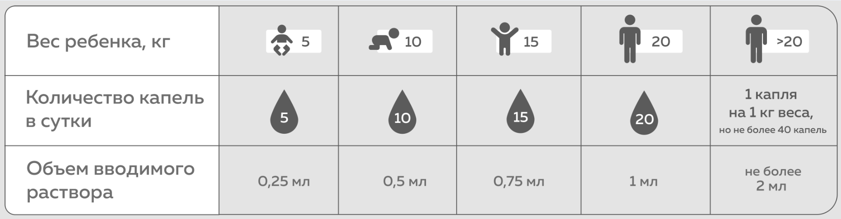

RUS | ENG
Вес ребенка, кг | Child’s body weight, kg
Количество капель в сутки | Number of drops per day
1 капля на 1 кг веса, но не более 40 капель | 1 drop per kg of body weight, but not more than 40 drops
Объем вводимого раствора | Amount of solution to administer
0,25 мл | 0.25 mL
0,5 мл | 0.5 mL
0,75 мл | 0.75 mL
1 мл | 1 mL
не более 2 мл | up to 2 mL

A daily amount should be administered nasally or sublingually in 3–4 doses over the day.
Use for 5–10 days.

Rules for sublingual and nasal administration

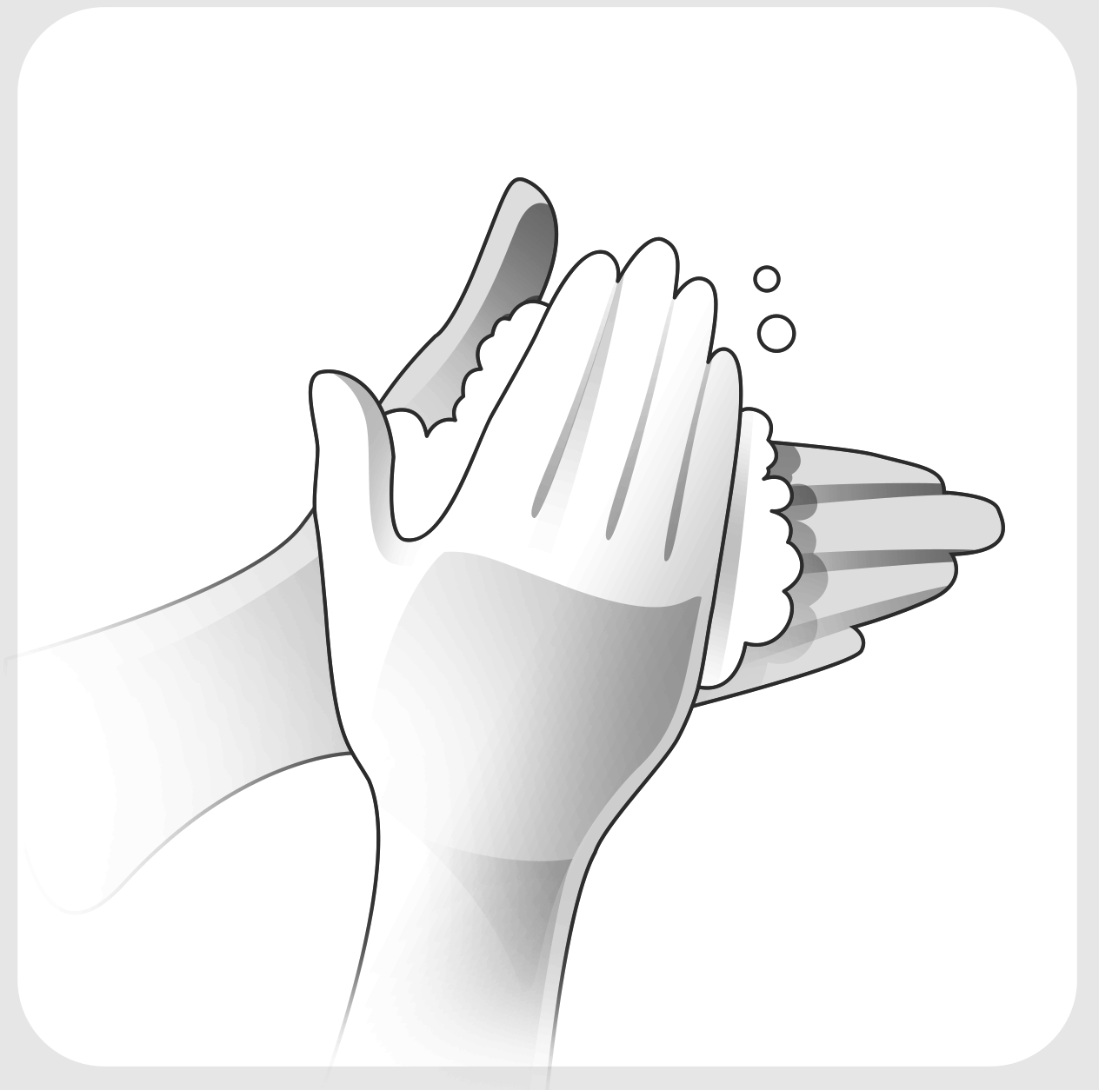 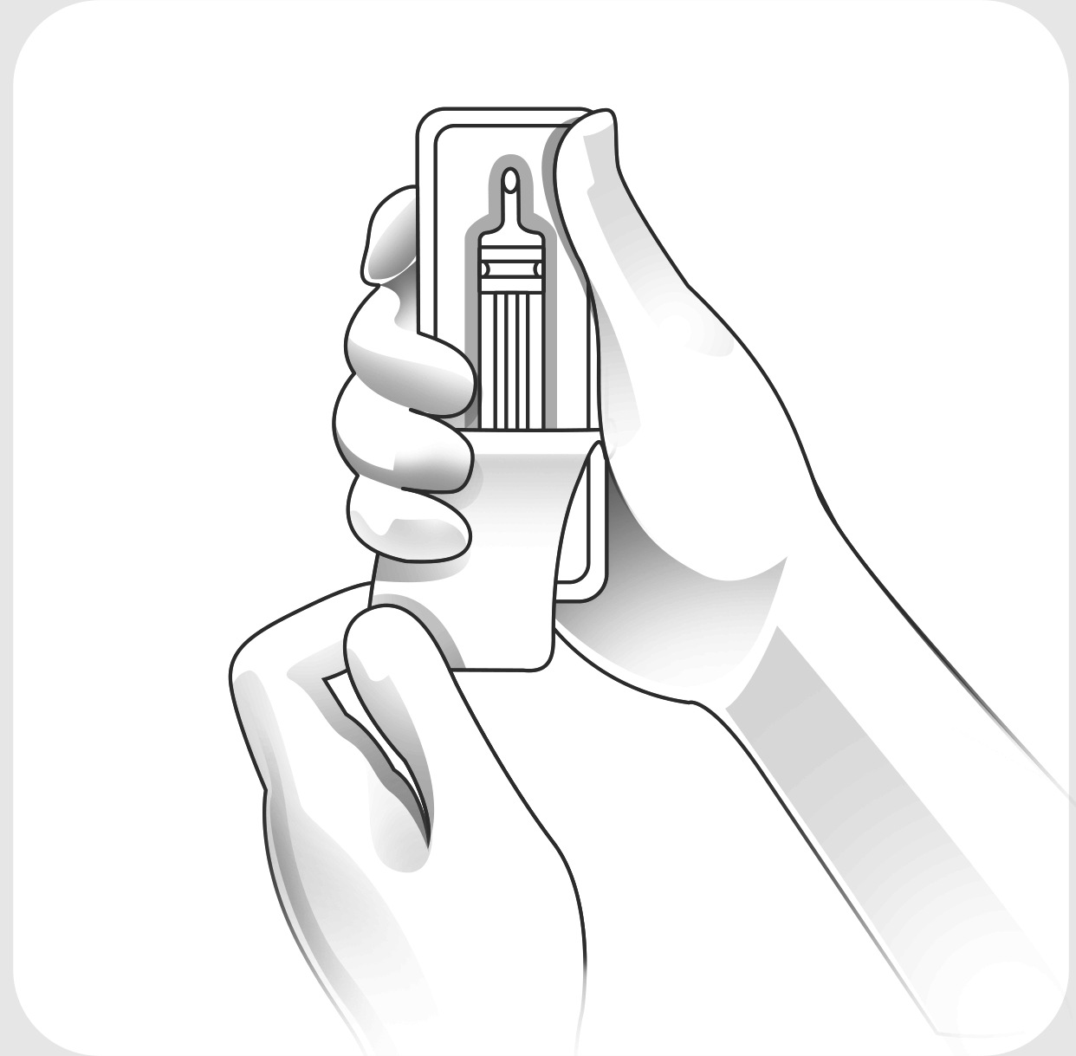 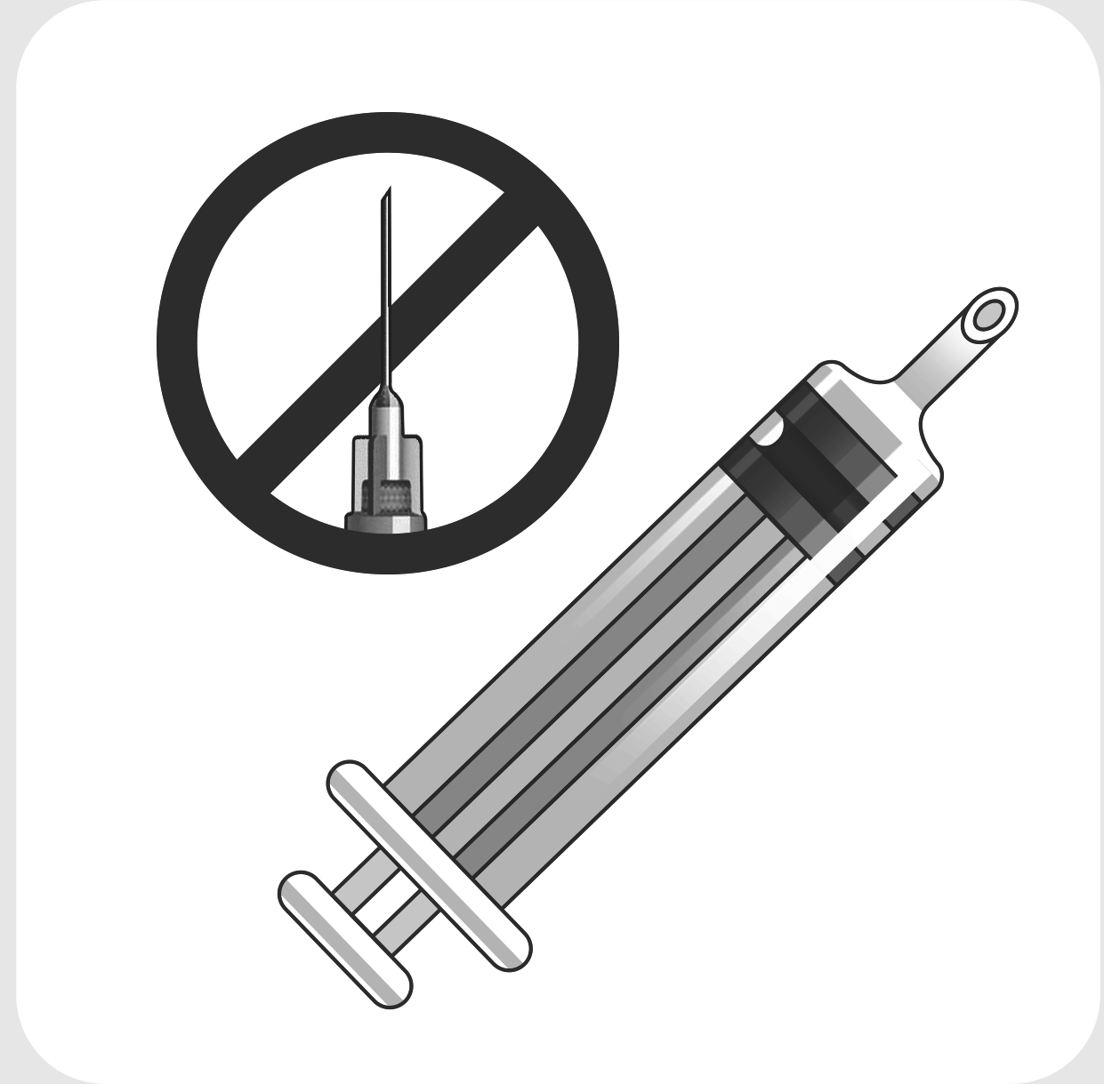
Fig. 1 Fig. 2 Fig. 3
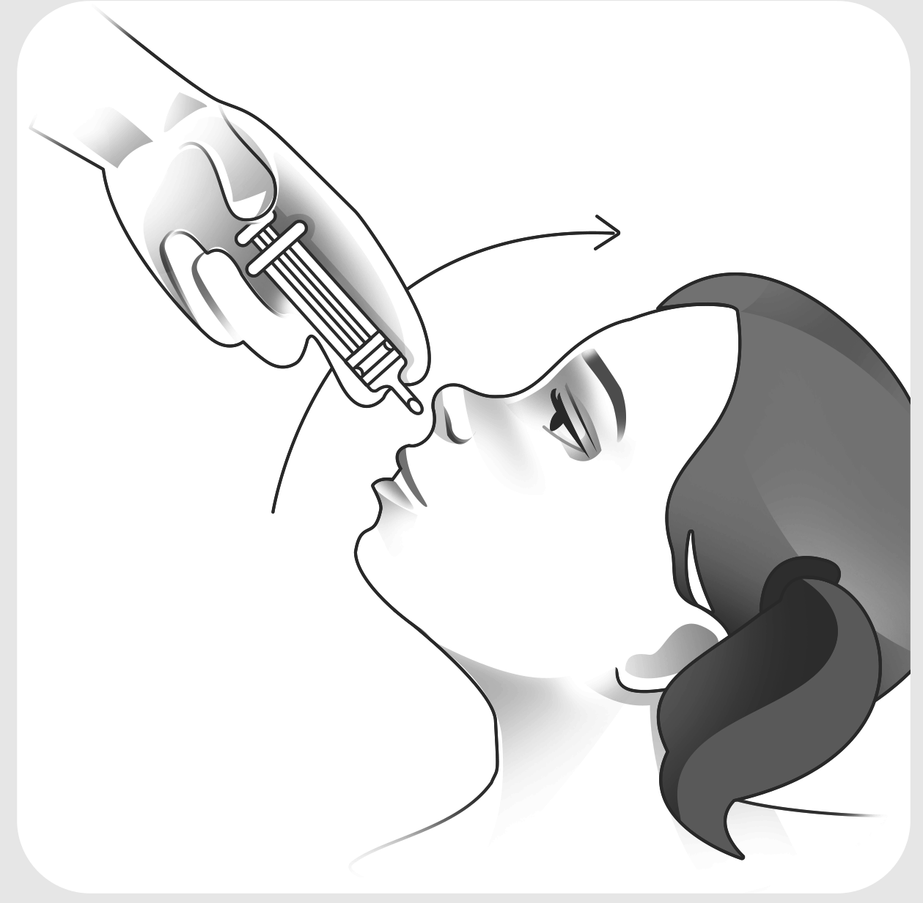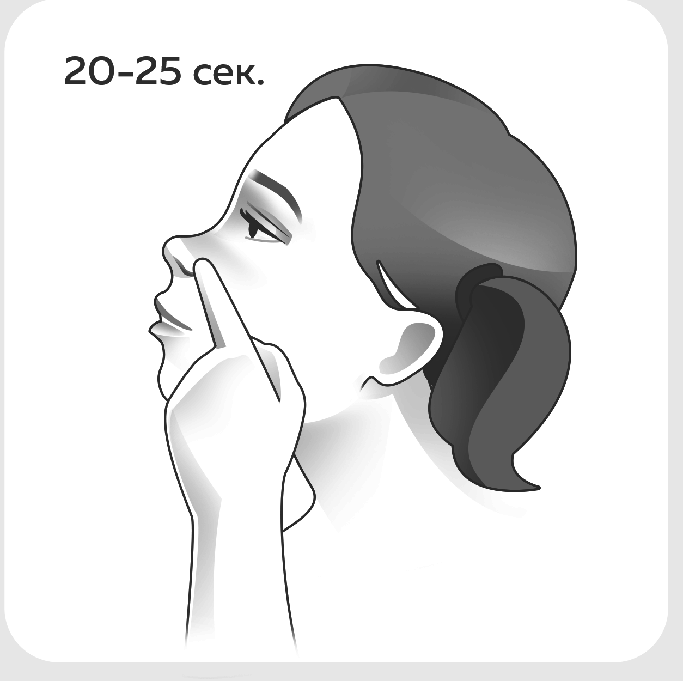
Fig. 4 Fig. 5 Fig. 6 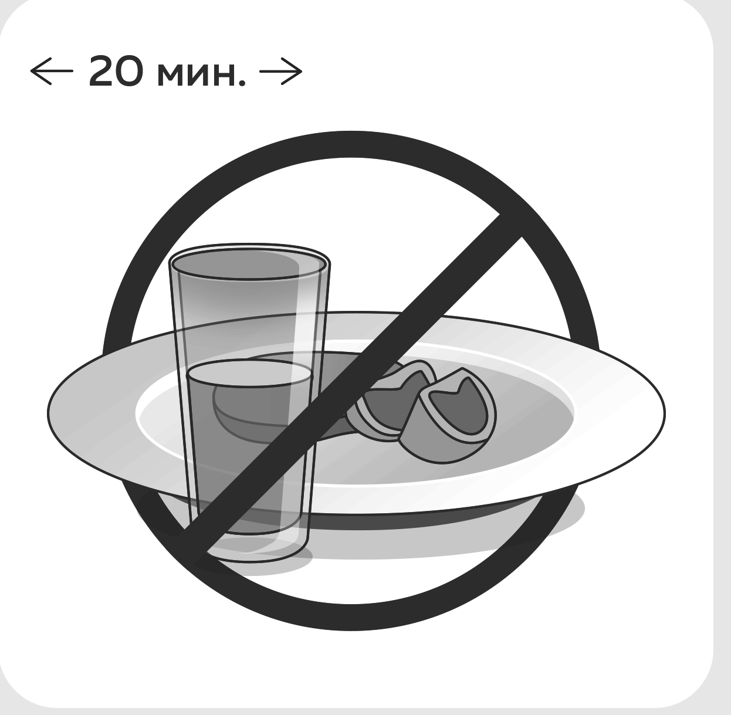 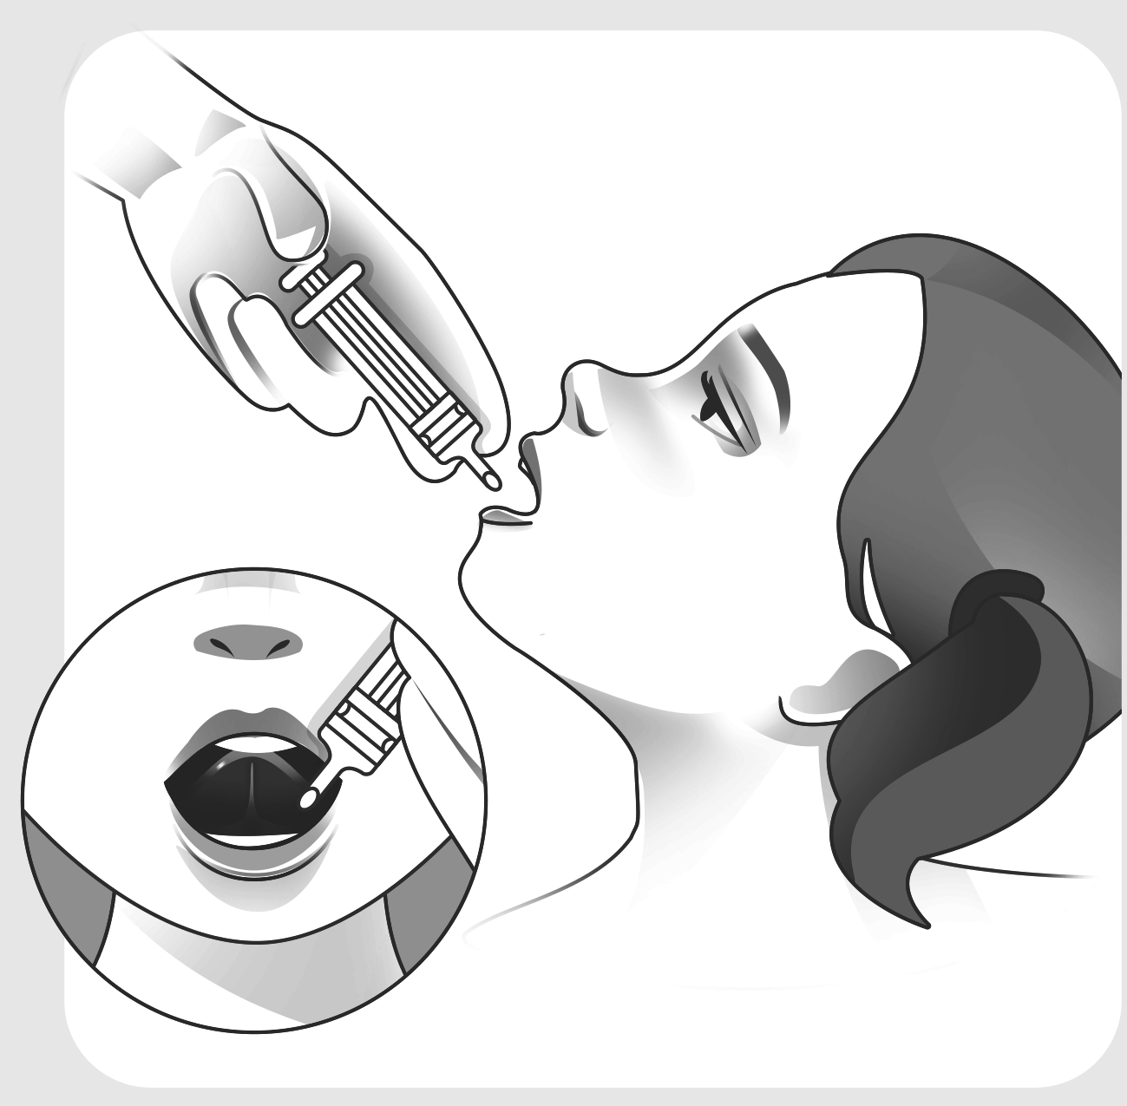
Fig. 7 Fig. 8 Fig. 9

Preparation for use
Figure 1. Wash your hands thoroughly.
Figure 2. Remove syringe from carton. Remove external individual plastic packaging.
Figure 3. Do not use needle to instill drops into nasal passages or under tongue.
To administer drug into nasal passages:
Figure 4. Remove mucus from nasal cavities.
Figure 5. Get yourself (or patient) into comfortable position (sit or lie on your back), with head tilted back slightly. Instill half of drops required into one nasal passage (see Tab. 1).
Figure 6. Press nostril against nasal septum with your finger to prevent solution from flowing out. Hold it for 20–25 seconds. Instill remaining dose into other nasal passage.
To administer drug sublingually:
Figure 7. Do not eat or drink for 20 minutes before and after administration.
Figure 8. Instill drops under tongue (see Tab. 1).
Figure 9. Drug has neutral taste and does not need to be taken with water.
After administration:
Place cap on syringe. Once unpacked, syringe used for nasal or sublingual administration can be stored in refrigerator for no more than 7 days.
Side effects
The following general and local reactions have been reported while using Polyoxidonium®:
Uncommon (≥ 1/1,000 to < 1/100): tenderness, redness or thickening of the skin at the site of parenteral administration.
Very rare (> 1/10,000): body temperature rising to 37.3°C, slight anxiety, chills during the first hour after injection.
If you notice any side effects not listed in the leaflet, please notify your doctor.
Overdose
No cases of overdose have been reported.
Drug interactions
Azoximer bromide does not inhibit cytochrome P-450 isoenzymes CYP1A2, CYP2C9, CYP2C19, CYP2D6; therefore, the medicinal product is compatible with many medications, including antibiotics, antiviral, antifungal and antihistamine agents, glucocorticosteroids, and cytostatics.
Special instructions
If an allergic reaction develops, you should stop using Polyoxidonium® and consult a doctor.
If you need to stop taking Polyoxidonium®, you can cancel it immediately, without a gradual dose reduction.
If the next dose of the medicinal product is missed, you should continue to use it as usual, in line with the instructions in this leaflet or a doctor’s recommendations. Do not take a double dose to compensate for the missed ones.
Do not use the medicinal product if there are visual signs of its unsuitability (a packaging defect, discoloration of the solution).
Do not dissolve in protein-bearing infusion solutions to administer via intravenous (drip) infusion.
Effects on ability to drive and use machines
The use of Polyoxidonium® does not affect the ability to perform potentially hazardous activities that require increased concentration of attention and speed of psychomotor reactions (including driving, operating moving mechanisms).
Dosage form
Solution for injections and topical application.
1.0 or 2.0 mL (for 3.0 mg/mL dosage) in 1 or 2 mL disposable injection syringes made of neutral glass.
1.0 mL (for 6.0 mg/mL dosage) in 1 mL disposable injection syringes made of neutral glass.
1.0 or 2.0 mL (for 3.0 mg/mL dosage) or 1.0 mL (for 6.0 mg/mL dosage) in 3 mL vials made of colorless glass.
1 syringe with 1 disposable sterile needle in a blister covered with aluminium foil. 5 vials in a blister. 1 blister together with the package leaflet placed in a carton.
5 blisters with 1 syringe and 1 disposable sterile needle each together with the package leaflet placed in a carton.
5 syringes with 5 disposable sterile needles each (without blisters) together with the package leaflet placed in a carton with a cardboard insert.
Shelf life
2 years. Do not use after expiration date.

Storage conditions
Store at 2–8°С.
Keep out of reach of children.
Pharmacy purchasing terms
Available on prescription.

Manufacturer / marketing authorization holder
Marketing authorization holder, and manufacturer:
NPO Petrovax Pharm LLC
Registered office / manufacturing site / address for customer complaints:
1 Sosnovaya St., Pokrov village, Podolsk, Moscow Region, 142143, Russia, tel./fax: +7 495 926 2107, e-mail: info@petrovax.ru;
For complaints: tel.: +7 495 730 2107, e-mail: adr@petrovax.ru

Head of Regulatory Affairs
for Russia and the EAEU
NPO Petrovax Pharm LLC M.P. Nosyreva

